Business Question and Visualization Report

Date | 8 Dec 2025
Team ID | SWUID20250222796
Project Name | Predicting Plant Growth-Stages with Environmental and Management Data Using Power BI
Maximum Marks | 5 Marks

Visualization development refers to the process of creating graphical representations of data to facilitate understanding, analysis, and decision-making. The goal is to transform complex datasets into visual formats that are easy to interpret, enabling users to gain insights and make informed decisions. Visualization development involves selecting appropriate visual elements, designing layouts, and using interactive features to enhance the user experience. This process is commonly associated with data visualization tools and platforms, and it plays a crucial role in business intelligence, analytics, and reporting
Business Questions and Visualisation
The process involves defining specific business questions to guide the creation of meaningful and actionable visualizations in Power BI. Well-framed questions help in identifying key metrics, selecting relevant data, and building visualisation that provide insights.
- Which combination of Soil Type and Watering Frequency yields the highest growth count?
Visualization:
Matrix/Cross-Tabulation Table showing growth counts segmented by two axes (Soil Type & Watering Frequency).
Screenshot of visualisation :

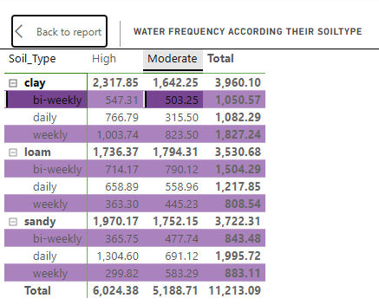

2.How does average temperature change across different temperature segments (Warm, Cold, Moderate)?
Visualization:
Waterfall Chart (as seen in the example) showing the contribution of each segmented level to the total average temperature.
Screenshot of visualisation :
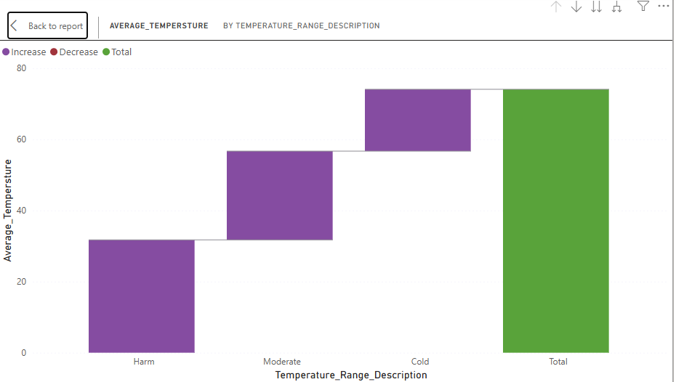

3.What is the current distribution of growth milestones across different Soil Types?
Visualization:
Sankey Diagram or Simple Bar Chart (as suggested by the visual) showing growth count by soil type (Loam, Sandy, Clay).
Screenshot of visualisation :
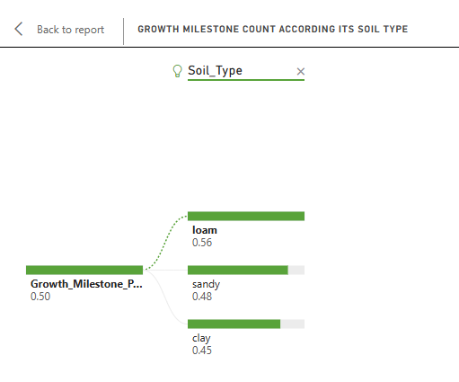

4. What is the percentage breakdown of growth milestones by Fertilizer Type?
Visualization:
Doughnut or Pie Chart comparing the ratio of growth milestones achieved under Organic, Chemical, and None.
Screenshot of visualisation :
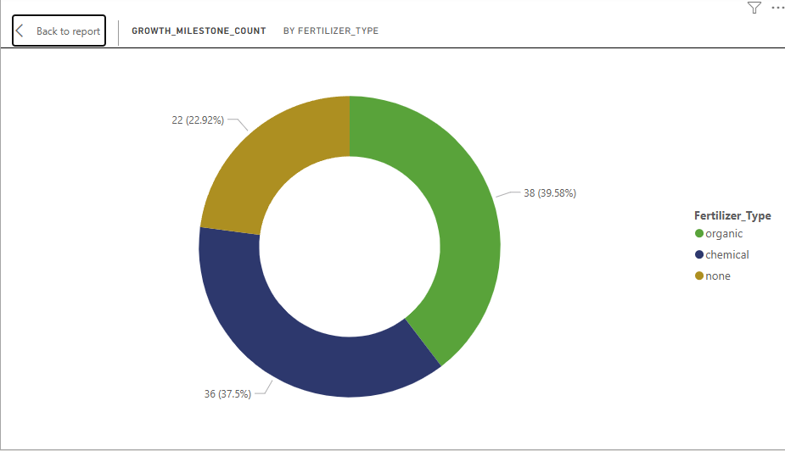
5. What factors significantly influence the increase or decrease in average temperature?
Visualization:
Power BI Key Influencers Visual showing the variables that drive the change in the Average Temperature metric.
Screenshot of visualisation :
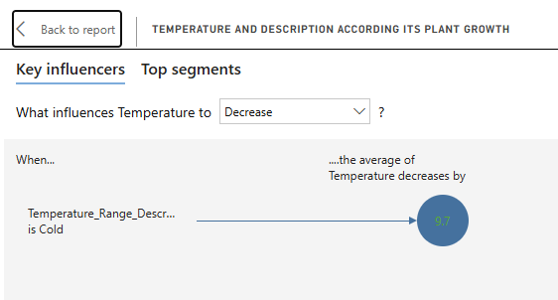

6. How does the average humidity change when categorized by defined humidity levels (Humid, Moderate, Dry)?
Visualization:
Bar Chart comparing the average humidity value for each categorized humidity level.
Screenshot of visualisation :
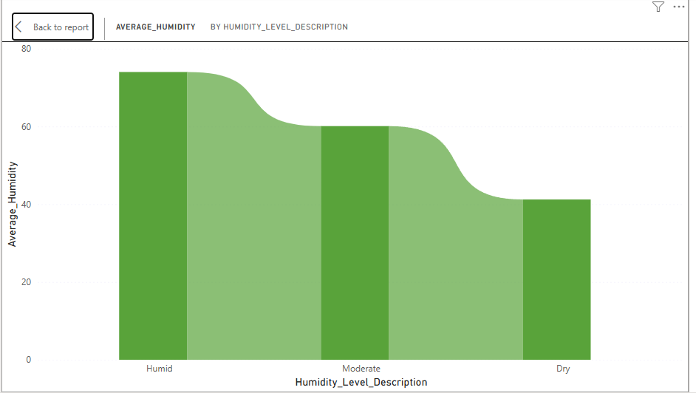
7. What is the total overall contribution of each Soil Type (clay, loam, sandy) to the total growth milestones?
Visualization:
Simple Column Chart (or the table summation) showing the grand total of growth milestones for each soil type.
Screenshot of visualisation:
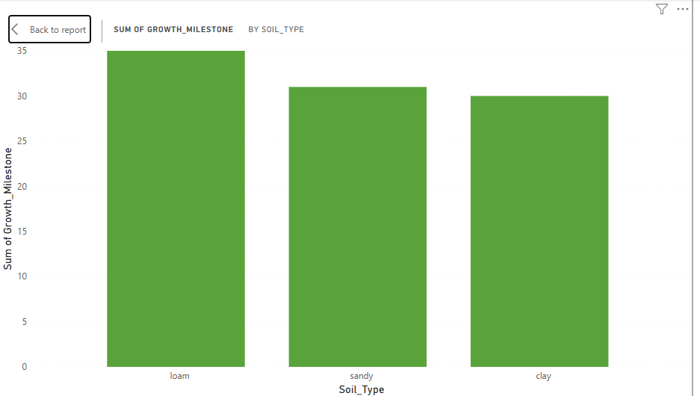

8. What is the total growth count achieved by weekly watering across all soil types?
Visualization:
Filter/Slicer used on the main table to show the total calculated value for the 'weekly' watering frequency row.
Screenshot of visualisation:
